1. Log in into Chronograf and go to tab which is related to alerts:

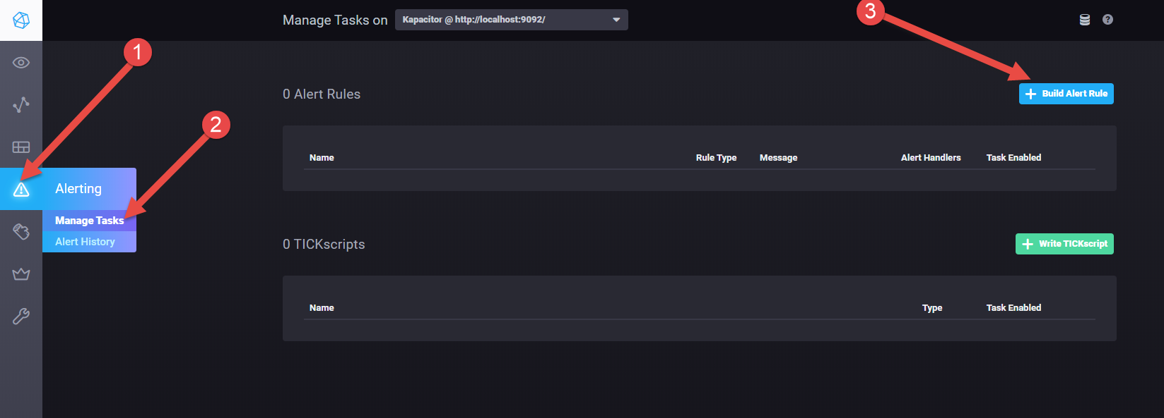

1. Create new alert:

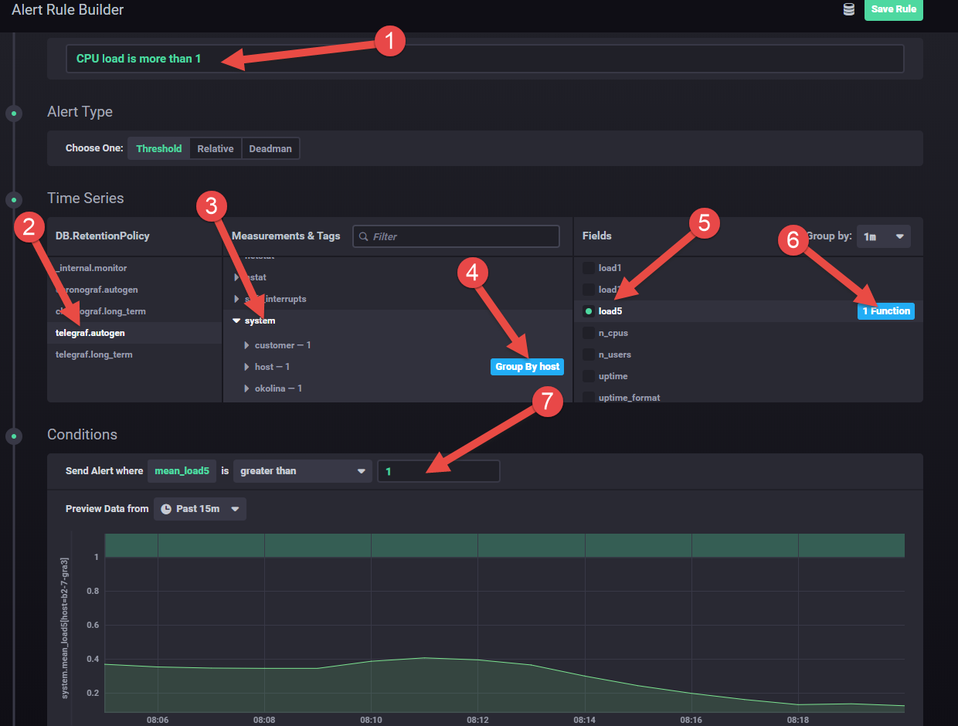

1 - Name of the alert

2 - Name of the DB where your metric is located

3 - Name of the measurement (table)

4 - Of you need to apply this alert for all servers need to choose - “Group By Host”

5 - Specify value which you want to monitor

6 - We should avoid spikes and false alerts, in this case you should apply function like - “check the average for the last 1 minute”

7 - Specify threshold. Alert will be triggered if: “average cpu load on some of the server for the last 1 minute will be more than 1”

1. Choose notification channel for your alerts

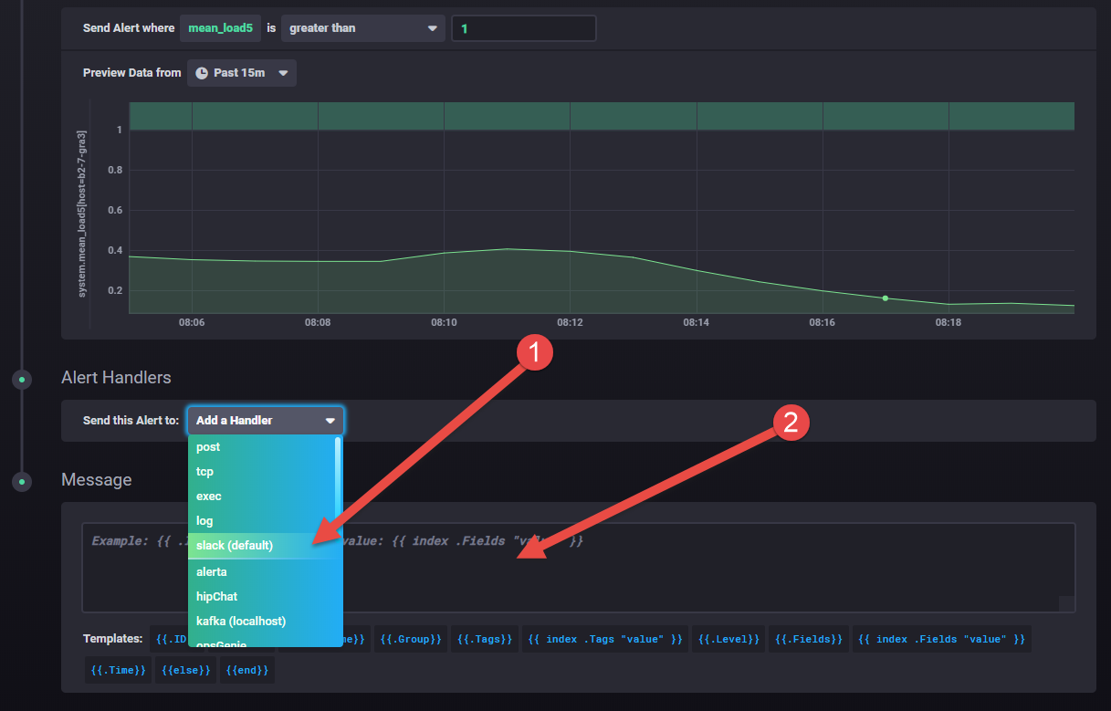

1 - You have multiple options to receive alerts and one of them is Slack

2 - You can specify custom message which you want to see inside alerts

1. Select Slack channel

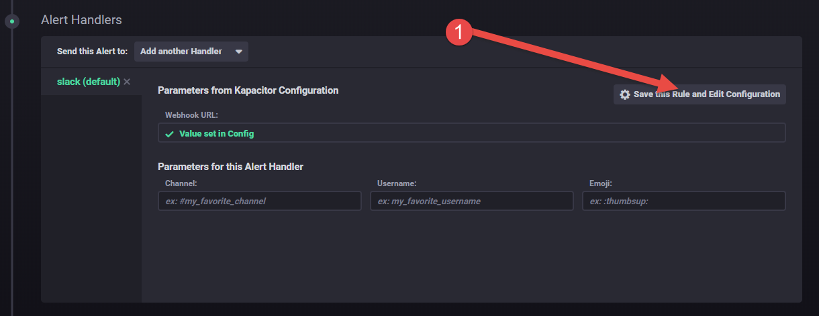

1. Configure Slack

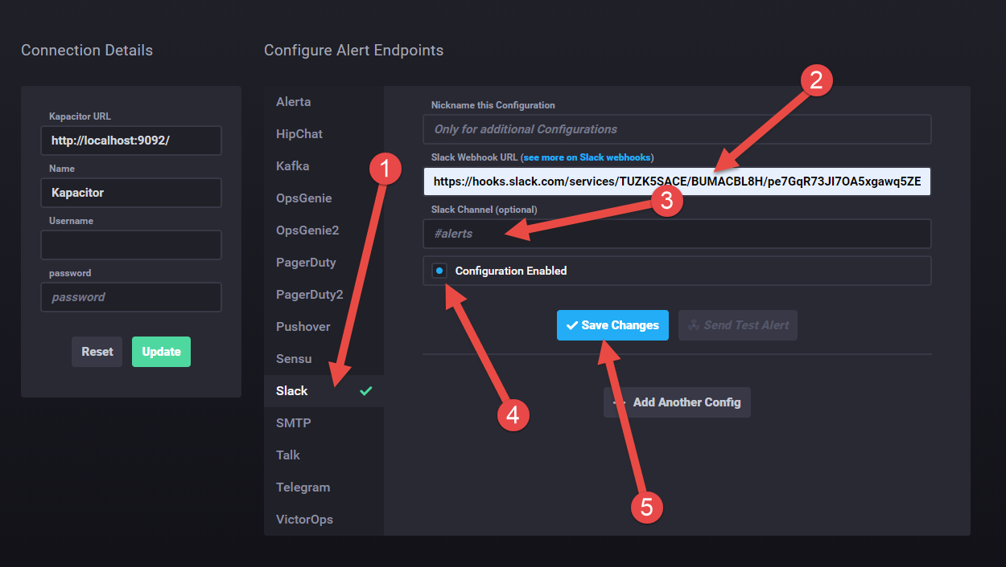

1 - Choose Slack

2 - Specify URL to your Slack Webhook. How to find URL - <https://slack.com/intl/en-gb/help/articles/115005265063-Incoming-webhooks-for-Slack>

3 - Specify name of the channel in Slack where you want to see alerts

4 - Enable this channel

5 - Save settings

1. Check list of alerts

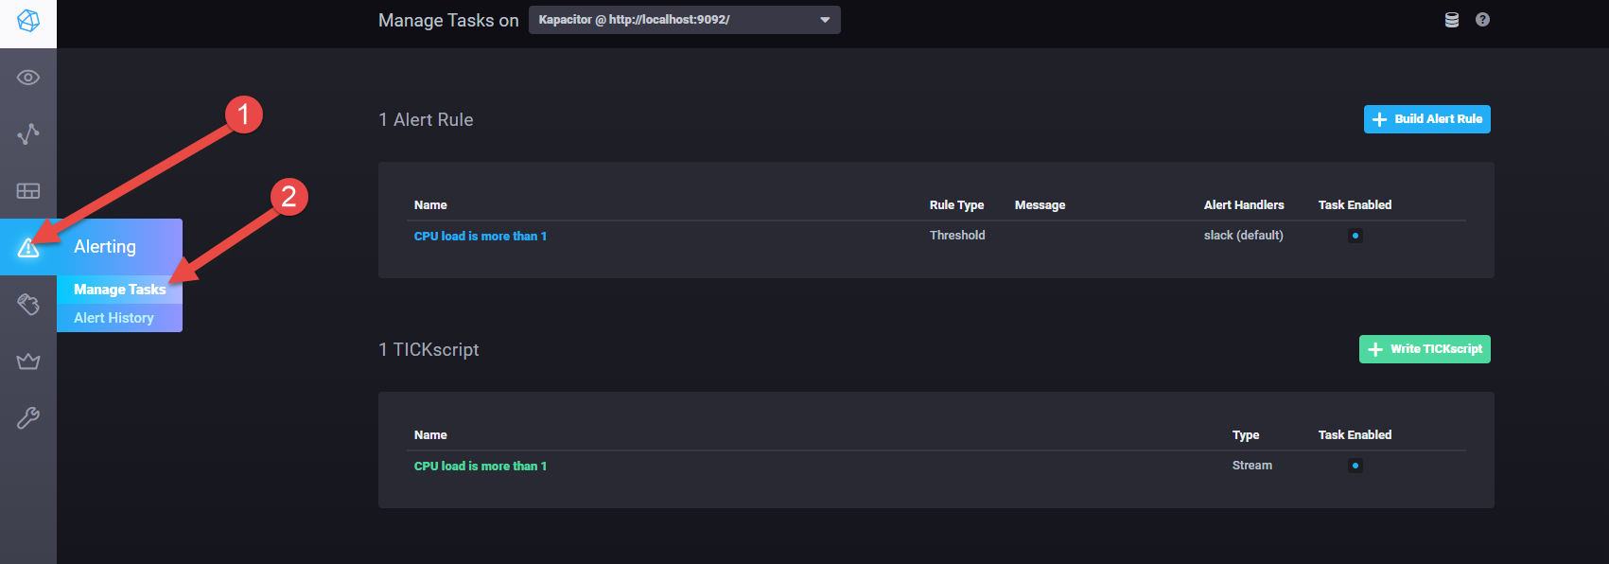

1. Check alerts history

